Web Usability and Information Architecture principles in games design and testing

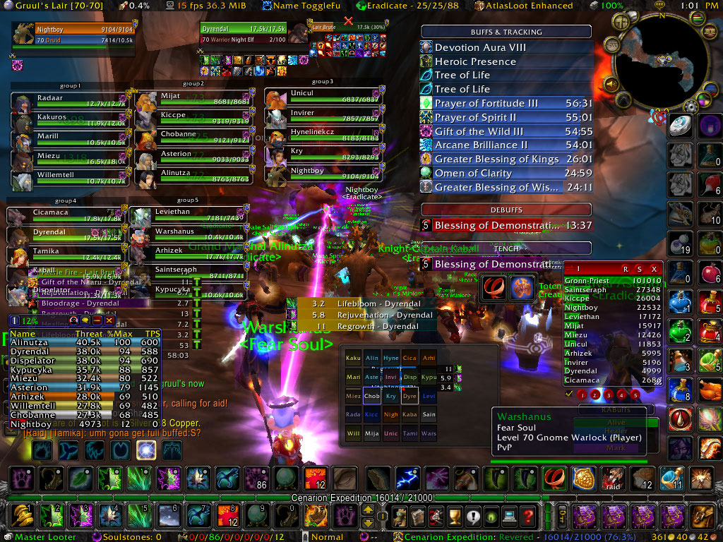

Kitman Yiu  
Subject: Application Testing & Metrics2  
Teacher: DONOLD COUTTS

CONTENT

[Introduction 2](#_Toc414607336)

[Information ARCHITECTURE (IA) 3](#_Toc414607337)

[History of Information ARCHITECTURE (IA) 3](#_Toc414607338)

[Definition 5](#_Toc414607339)

[Goal of IA 6](#_Toc414607340)

[Componets of IA 6](#_Toc414607341)

[Venn diagram 6](#_Toc414607342)

[Structures 7](#_Toc414607343)

[Examples 8](#_Toc414607344)

[Web usability PRINCIPLES (WUP) 9](#_Toc414607345)

[defention 9](#_Toc414607346)

[Goal of WUP 10](#_Toc414607347)

[Components Of WUP 10](#_Toc414607348)

[Principles of usability desgin In web 10](#_Toc414607349)

[Jakob Nielsen's 10 general principles 12](#_Toc414607350)

[Applying IA and WUP to Game Development 13](#_Toc414607351)

[Game 13](#_Toc414607352)

[Defention 15](#_Toc414607353)

[IA and Game 15](#_Toc414607354)

[WUP and Game 16](#_Toc414607355)

[Conclision 19](#_Toc414607356)

# Introduction

|  |  |  |  |
| --- | --- | --- | --- |
| |  |  | | --- | --- | | C:\Users\Kitman\Google Drive\School\==CIT==\2015_Application Testing & Metrics\Assigment 2\Pictures\q9i1i76os9cvzve8o0mg.png |  | | C:\Users\Kitman\Google Drive\School\==CIT==\2015_Application Testing & Metrics\Assigment 2\Pictures\wowscrnshot101407130246ml3.jpg |

From the above images most of you will agree compare to right the left image is easier to find the information (e.g. image or word in the game) that you want, so how can the right image be design to allow people to find information more easily?

Answer is **Information architecture**. Information architecture is **how information are represent to the user.** The **goal** of is to ensure the information are **comprehensiveness, usability, relevance and query performance.**

In this paper we are going to talk about Information architecture (IA) and also web usability principles (WUP). After that we are going to give an example that how (IA) and WUP can be applied to game development. The following image is the diagram that represent the connections between IA and WUP.

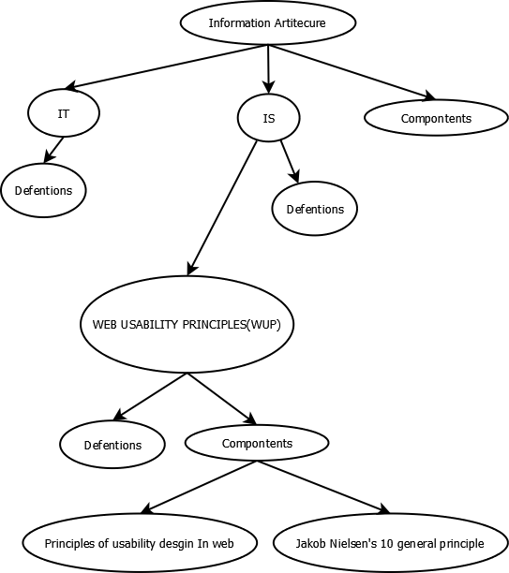

After that we will give an example of how can IA and WUP be applied to game development.

# Information ARCHITECTURE (IA)

## History of Information ARCHITECTURE (IA)

**(According to, Information architecture - Wikipedia, the free encyclopedia. 2015) and**

**(A Brief History of Information Architecture. 2015.)**

Back to mid-1970s and Richard Saul Wurman’s famous address at the American Institute of Architecture conference of 1976, use of the term information together with the term architecture has been around for a little bit longer and in quite a few different settings. In an IBM research paper written in 1964, some 12 years before Wurman, and entitled “Architecture of the IBM System/360” (Amdahl et al 1964), architecture is defined as

The conceptual structure and functional behavior, distinguishing the organization of data flows and controls, logical design, and physical implementation.

It is not disputable that we are talking computer architectures here, disks and boxes and wires and hubs, but the way in which the term architecture is abstracted and conceptualized in connection with structure and behavior and not just physical layouts laid the basis for the subsequent extension of its use to other areas of computing.

A few years later, in 1970, at the Xerox Palo Alto Research Center (PARC), a group of people specialized in information science was assembled and then given the charter to develop technology which could support the “architecture of information” (Pake 1985). This group was single-handedly responsible for a number of important contributions in what we would call today the field of human-computer interaction, including the first personal computer with a user-friendly interface, laser printing, and the first WYSIWYG text editor.

Weitzman (1995) supports this notion that the modern inception of the term originally came from Xerox Labs. Quoting Smith and Alexander (1988), Weitzman maintains that

Xerox was among the first corporations to address this notion of information structure and use the “elegant and inspiring phraseology, the architecture of information” to define its new corporate mission.

This high-level framing, the necessity for a broader vision, remained one of the core concepts for those who wrote about information architecture up to the mid-1980s, as much as this joining of specialists in information science and in user-focused development (Ronda León 2008), a trait that will be somehow brought to greater visibility and results by the first wave of modern information architects in the 1990s.

From the mid-1980s, information architecture seemingly went through a dormant period, during which the idea of information architecture as both the design of complex or dynamically changing information seemed to be lost to a view much more akin to that of information systems. Articles written in those years mostly refer to information architecture as a tool for the design and creation of computer infrastructures and data layers, with a larger emphasis on the organizational and business aspects of the information networks (Morrogh 2003).

Curiously enough, much of the design deliverables we associate with information architecture today are a product of this period: blueprints, requirements, information categories, guidelines on the underlying business processes, global corporate needs, they all make their way into information architecture-related territory in the 1980s (Brancheau & Wetherbe 1986). They will be incorporated once and for all in the information architect’s toolkit by the wave of the late 1990s lead by Rosenfeld and Morville.

An image is represent below of the history of IA:

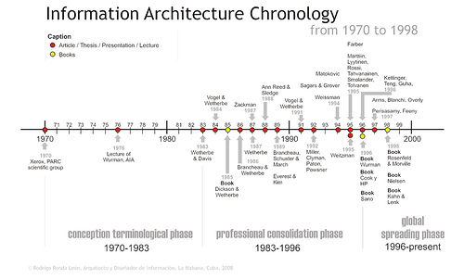

## Definition

**(According to, Information architecture - Wikipedia, the free encyclopedia. 2015.)**

Information architecture (IA) has different definitions in different branches of IS or IT

1. The structural design of shared information environments.
2. The art and science of organizing and labeling web sites, intranets, online communities, and software to support findability and usability.
3. An emerging community of practice focused on bringing principles of design and architecture to the digital landscape.
4. The combination of organization, labeling, search and navigation systems within websites and intranets.
5. Extracting required parameters/data of Engineering Designs in the process of creating a knowledge-based linking different systems and standards.

The difficulty in establishing a common definitionfor "information architecture” the reason can be showed by an example, the information architecture is a part of enterprise that deals with the information component when describing the structure of an enterprise. So the definition of information architecture is defined well enough in the field of systems design, it is much more debatable within the context of online information systems (i.e., websites). Andrew Dillon refers to the latter as the "big IA-little IA debate”. In the little IA view, the fact is information architecture is the application of information science to web design, for example, To solve the issues of classification and information retrieval, in the big IA view, information architecture involves more than just the organization of a website; it also includes [user experience](http://en.wikipedia.org/wiki/User_experience), thereby considering [usability](http://en.wikipedia.org/wiki/Usability) issues of [information design](http://en.wikipedia.org/wiki/Information_design).

## Goal of IA

**(According to, Blog 2 – Information Architecture « Zhao Pu. 2015.)** The purpose of IA is that the information are

* Comprehensiveness
* Usability
* Relevance
* Query performance

## Componets of IA

**(According to, Blog 2 – Information Architecture « Zhao Pu. 2015.)**

**Main components of IA** waspublish by a book called “Information Architecture for the World Wide Web” and note the following components

* Organization System
* Labeling Systems
* Navigation Systems
* Search Systems

|  |  |  |  |
| --- | --- | --- | --- |
| Organization System | **Labeling Systems** | **Navigation Systems** | **Search Systems** |
| Schemes and Structures: How you categorize and structure information | How you represent information | How users browse or move through information | How users look for information |

### Venn diagram

**(According to, Blog 2 – Information Architecture « Zhao Pu. 2015.)**

In order to **create** these **systems of information**, Rosenfeld and Morville referred to this as the “information ecology” and visualized it as a **venn diagram.**

**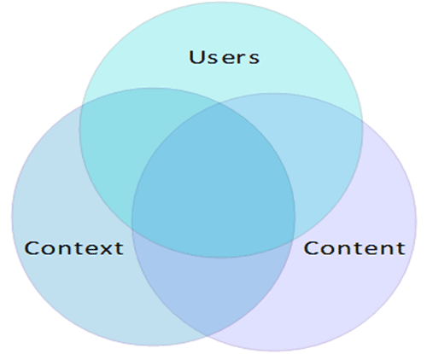**

|  |  |  |
| --- | --- | --- |
| **Context** | **Content** | **Users** |
| Business goals, funding, politics, culture, technology, resources, constraints | Content objectives, document and data types, volume, existing structure, governance and ownership | Audience, tasks, needs, information-seeking behavior, experience |

### Structures

**(According to Basic Information Structures. 2015.)**

**Jesse James Garrett** in the "**Elements of user experience: classification information about the structure of the product user centered design**" and notice the following structure

|  |  |
| --- | --- |
| C:\Users\Kitman\Google Drive\School\==CIT==\2015_Application Testing & Metrics\Assigment 2\Pictures\sequential.png | C:\Users\Kitman\Google Drive\School\==CIT==\2015_Application Testing & Metrics\Assigment 2\Pictures\hierarchical.png |
| **Sequential structures** | **Hierarchical structures** |
| C:\Users\Kitman\Google Drive\School\==CIT==\2015_Application Testing & Metrics\Assigment 2\Pictures\matrix.png | **C:\Users\Kitman\Google Drive\School\==CIT==\2015_Application Testing & Metrics\Assigment 2\Pictures\organic.png** |
| **Matrix structures** | **Organic structures** |

This can be explain if have time

## Examples

Assuming we are going to make portfolio webpage

The following things can be included that related to IA:

1. The pages that you design
2. What things are in the pages are how are they going to been see by user

|  |  |
| --- | --- |
| C:\Users\Kitman\Google Drive\School\==CIT==\2015_Application Testing & Metrics\Assigment 2\Pictures\0344-12_sitemap_information_architecture.jpg | C:\Users\Kitman\Google Drive\School\==CIT==\2015_Application Testing & Metrics\Assigment 2\Pictures\Information-Architecture.jpg |

A game that I recently play is a good example as well, I was trying to find the tool delete the road but I couldn’t , so I gone up the internet and have a search using 30 minutes and then gave up ,and finally one time I saw it was actually cover by a box , show as the following image:

|  |  |
| --- | --- |
| C:\Users\Kitman\Desktop\Capture.PNG | C:\Users\Kitman\Desktop\Capture2.PNG |

The button I was finding

Cover by this box

# Web usability PRINCIPLES (WUP)

## defention

**(According to, Usability 101: Introduction to Usability. 2015)**

Web usability principles means:

Some rules that allow people to

* Learnability
* Efficiency
* Memorability
* Errors
* Satisfaction

, in the web

|  |  |
| --- | --- |
| **Learnability** | **Efficiency** |
| How easy is it for users to accomplish basic tasks the first time they encounter the design? | Once users have learned the design, how quickly can they find there information? |
| **Memorability** | **Errors** |
| When users return to design after a period of not using it, how easily can they will they pick it up? | How many errors do users make, how severe are these errors, and how easily can they recover from the errors? |
| **Satisfaction** |  |
| How pleasant is it to use the design? |  |

## Goal of WUP

**(According to 5 Basic Usability Principles Every Website Should Follow. 2015)**

The are two main **goals** of **WUP**

* Save user’s time by making everything clear, easy and accessible.
* Increase satisfaction from the website experience and prevent negative response.

## Components Of WUP

Principles of usability desgin In web

Many people in the usability community regard **Steve Krug’s** book “[**Don’t Make Me Think: A Common Sense Approach to Web Usability, 2nd Edition**](http://www.amazon.com/gp/product/0321344758?ie=UTF8&tag=ux-booth-20&linkCode=as2&camp=1789&creative=390957&creativeASIN=0321344758)”http://www.assoc-amazon.com/e/ir?t=ux-booth-20&l=as2&o=1&a=0321344758 as the laypersons usability bible. Detentions were be study by current areas

**(10 Principles Of Effective Web Design - Smashing Magazine. 2015)**

**(Excerpt from Ch 1 of Steve Krug's Don't Make Me Think. 2015.)**

* USABILITY MEANS…
* WEB APPLICATIONS SHOULD EXPLAIN THEMSELVES.
* DON’T MAKE ME THINK
* DON’T WASTE MY TIME
* USERS STILL CLING TO THEIR BACK BUTTONS
* WE’RE CREATURES OF HABIT
* NO TIME FOR SMALL TALK
* DON’T LOSE SEARCH
* WE FORM MENTAL SITE-MAPS
* MAKE IT EASY TO GO HOME

|  |  |  |
| --- | --- | --- |
| 1 | 2 | 3 |
| Usability means making sure something works well, and the person have average ability or experience that can use it without getting hopelessly frustrated. | As far as humanly possible, when I look at a web page it should be self-evident. Obvious. Self-explanatory. | People don’t like to puzzle over how to do things. Things should be obvious. |
| 4 | 5 | 6 |
| Much of our web use is motivated by the desire to save time. As a result, web users tend to act like sharks. They have to keep moving or they’ll die. | If something’s go wrong, people should just need to press the back button is the most-used feature of web browsers. | Once we find something that works — no matter how badly — we tend not to look for a better way. We’ll use a better way if we stumble across one, but we seldom look for one. |
| 7 | 8 | 9 |
| Most Web users don’t want small talk; they want to get right to the beef. You can – and should – eliminate as much talk as possible. | Some people (search-dominant users), will nearly always look for a search box as they enter a site. | When we return to something on a Web site, instead of relying on a physical sense of where it is, we have to remember where it is in the conceptual hierarchy and retrace our steps. |
| 10 |  |  |
| Having a home button in sight at all times offers reassurance that no matter how lost I may get, I can always start over, like pressing a Reset button or using a “Get out of Jail free” card. |  |  |

Jakob Nielsen's 10 general principles

**(According to,10 Heuristics for User Interface Design: Article by Jakob Nielsen. 2015)**

For an interaction design. They are called "heuristics" because they are broad rules of thumb and not specific usability guidelines. The 10 rules are listed below

* ****Visibility of system status****
* ****Match between system and the real world****
* ****User control and freedom****
* ****Consistency and standards****
* ****Error prevention****
* ****Recognition rather than recall****
* ****Flexibility and efficiency of use****
* ****Aesthetic and minimalist design****
* ****Help users recognize, diagnose, and recover from errors****
* ****Help and documentation****

**(According to, Usability testing - Wikipedia, the free encyclopedia. 2015)**

To able to tell is the **information usability** we can **do** some **test**, Usability testing is a technique used in [user-centered](http://en.wikipedia.org/wiki/User-centered_design) [interaction design](http://en.wikipedia.org/wiki/Interaction_design) to evaluate a product by testing it on users, and the following technique are listed below:

* Hallway testing
* Remote Usability Testing
* Expert review
* Automated expert review
* A/B testing

# Applying IA and WUP to Game Development

## Game

So for now assuming that we needed to redesign to following game called World of Warcraft:



For more information of the game please go this following link: <http://us.battle.net/wow/en/>

A player named ??? which have been playing World of Warcraft 9 years pointed out there are multi design problem during the battle

This is an image “ ” showed me what things as unless in the battle

**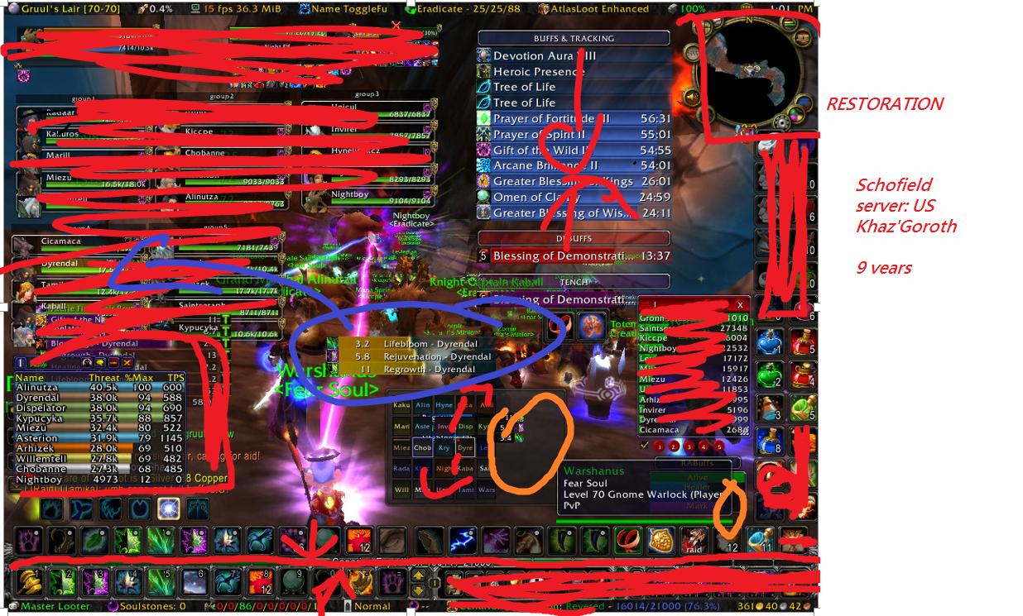**

**Bad design:**

Overlapping image

Some images too big

Repeated information

Showing the too much unless information: money does not need to include in the battle

Information was separated too much: teammate’s information

Names was repeat too much and all parts of the screen

**Good design:**

A good tutorial

Less word, more image the reason

Images should be bigger the text

## Defention

First of all we would need to have a definition but since there is no definition in game development for IA. I will wanted to recommend the following definition:

## IA and Game

As we know that to goal is to **comprehensiveness, usability, relevance and query performance**

From the above image we can see the game has **comprehensiveness information** (eg: enemy health, teammate’s health, chatting information ….. )

But not for **usability information,** because some of the information are unless for example: other teammates health is unless in a battle

For **relevance information** as a beginner there is no way to know what information are useful and what are not

And for **query performance** it is terrible, because there are too much information, which even the information are overlapped in the game.

To organize our information we can use **Hierarchical structures**tostructure from up to down

The most important will go to the top and unless information will go to the bottom showed by the following image:

## WUP and Game

Following by the **rules** from **Steve Krug’s** we can **apply** some rule in our **game** such as

|  |  |  |  |
| --- | --- | --- | --- |
| **USABILITY MEANS…** | **WEB APPLICATIONS SHOULD EXPLAIN THEMSELVES.** | **DON’T MAKE ME THINK** | **DON’T WASTE MY TIME** |
| This can same to same. | Player should after clicking all the action the player should know what they are doing | Players don’t want to think where the buttons , so limit maybe 3 click to the task we be good | Always allow people to find information easily of they forget some stuff |
| **WE’RE CREATURES OF HABIT** | **DON’T LOSE SEARCH** | **WE FORM MENTAL SITE-MAPS** | **MAKE IT EASY TO GO HOME** |
|  | It should allow us easily switch between the game scene and the menu scene |  | The user should be able to go back to the main menu easily by clicking not more than 2 buttons |

Following by the **rules** from **Steve Krug’s** these rules **can’t be apply**

|  |  |
| --- | --- |
| **USERS STILL CLING TO THEIR BACK BUTTONS** | **NO TIME FOR SMALL TALK** |
| **No back button in game** | **Different players and different game have different task some case there need to be a small talk about the game.** |

Following by the **rules** from **Jakob Nielsen’s** we can **apply** the following rule

|  |  |  |
| --- | --- | --- |
| **Visibility of system status** | **User Control and freedom** | **Consistency and standards** |
| * User should be able to regionize what buttons are able to click and what are not * The system should have different images after the button is click | * If the user click open some panel there are a X button of the right hand side of the Conner **to close the window** | * Symbols should related to the image that what action they are doing. |
| **Error prevention** | **Recognition rather than recall:** | **Asthetic and minimalist design** |
| * This rule can be … in game , since pressing the wrong button doesn’t effect a lot |  | * Only shows the information are need in the game      * The most important information should be bigger and the less important information should be smaller |
| **Help users recongnize , and recover from errrors** | **Help and documentation:** | **Match between system and the real world** |
| * After the user click the wrong button it should allow us to go to a panel which allow us to click the right botton | * If there are more than 15 buttons that the user will always click , they should create an online document * Game tutorials should be showed up in the game menu which * Tutorials can be either No tips , one tips, and always have tips | * The words in the game should matches the game which are similar to other type of games * User should know what state are they in (eg : battle state , idle state) * If no similar game was exists, make sure user can understand the word by doing a action. |
| **Flexibility and efficiency of use** |  |  |
| * **The game should both have shortcuts and buttons** |  |  |

**To apply the rules from the top we need to redesign the game.** After redesign the game the result should be

**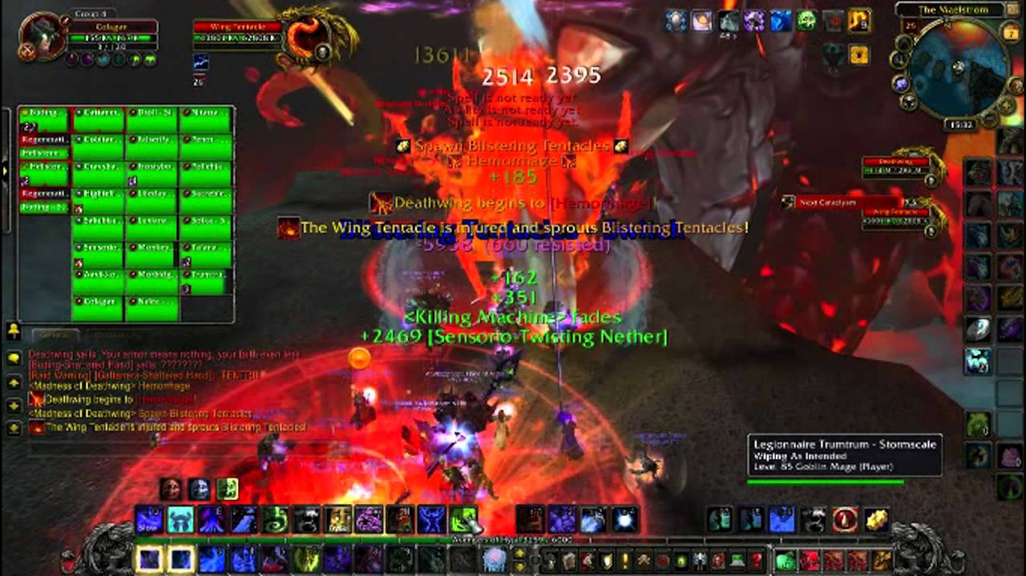**

But for us to ensure the design we should do the following testing method:

* **Hallway testing**
* **Remote Usability Testing**
* **Expert review**
* **Automated expert review**
* **A/B testing**

To able to know is the result success. I preferred that at 90% of person that plays your game can understand how to play your game.

Document are also required to record the success and failure design, a sample for the documentation are present below:

# Conclision

The goal of information architecture is comprehensiveness, usability, relevance and query performance something. And Web usability PRINCIPLES is some guideline for web to how to achieve information architecture (IA) . IA is a really big range of things include information and data life cycles that we didn’t show in this paper. To be able to define IA in game development we would need to do a really wide range of research of all the types of games and find a common definition, which this research can be more than 100 pages.

**NEED SOMEONE TO CHECK**

**Reference**

Information architecture - Wikipedia, the free encyclopedia. 2015.Information architecture - Wikipedia, the free encyclopedia. [ONLINE] Available at: <http://en.wikipedia.org/wiki/Information_architecture>. [Accessed 19 March 2015].

Blog 2 – Information Architecture « Zhao Pu. 2015. Blog 2 – Information Architecture « Zhao Pu. [ONLINE] Available at:<https://zhaopu.wordpress.com/2014/09/01/blog-2-information-architecture-2/>. [Accessed 19 March 2015].

Basic Information Structures. 2015. Basic Information Structures. [ONLINE] Available at:<http://desource.uvu.edu/dgm/2740/IN/steinja/lessons/02/l02_05.html?m=1>. [Accessed 19 March 2015].

A Brief History of Information Architecture. 2015. A Brief History of Information Architecture. [ONLINE] Available at:<http://journalofia.org/volume3/issue2/03-resmini/>. [Accessed 19 March 2015].

Usability 101: Introduction to Usability. 2015. Usability 101: Introduction to Usability. [ONLINE] Available at: <http://www.nngroup.com/articles/usability-101-introduction-to-usability/>. [Accessed 19 March 2015].

 5 Basic Usability Principles Every Website Should Follow. 2015. 5 Basic Usability Principles Every Website Should Follow. [ONLINE] Available at:<http://despreneur.com/5-basic-usability-principles-every-website-should-follow/>. [Accessed 19 March 2015].

10 Principles Of Effective Web Design - Smashing Magazine. 2015. 10 Principles Of Effective Web Design - Smashing Magazine. [ONLINE] Available at: <http://www.smashingmagazine.com/2008/01/31/10-principles-of-effective-web-design/>. [Accessed 19 March 2015].

Excerpt from Ch 1 of Steve Krug's Don't Make Me Think. 2015. Excerpt from Ch 1 of Steve Krug's Don't Make Me Think. [ONLINE] Available at:<http://desource.uvu.edu/dgm/2740/IN/steinja/docs/krug-dont_make_me_think/ch01/krug-ch01.html?m=1>. [Accessed 19 March 2015].

Excerpt from Ch 1 of Steve Krug's Don't Make Me Think. 2015. Excerpt from Ch 1 of Steve Krug's Don't Make Me Think. [ONLINE] Available at:<http://desource.uvu.edu/dgm/2740/IN/steinja/docs/krug-dont_make_me_think/ch01/krug-ch01.html?m=1>. [Accessed 19 March 2015].

Towards a New Information Architecture. 2015. Towards a New Information Architecture. [ONLINE] Available at: <http://eleganthack.com/towards-a-new-information-architecture/>. [Accessed 19 March 2015].

如何做信息架构设计. 2015. 如何做信息架构设计. [ONLINE] Available at:<http://www.slideshare.net/iambacchus/ss-1801047>. [Accessed 19 March 2015].

可用性\_百度百科. 2015. 可用性\_百度百科. [ONLINE] Available at:<http://baike.baidu.com/view/1436.htm>. [Accessed 19 March 2015].

Usability 101: Introduction to Usability. 2015. Usability 101: Introduction to Usability. [ONLINE] Available at: <http://www.nngroup.com/articles/usability-101-introduction-to-usability/>. [Accessed 19 March 2015].

你真的懂得尼尔森的十大可用性原则么？|理论|原创/自译教程|grovergao - 设计文章/教程分享 - 站酷 (ZCOOL). 2015. 你真的懂得尼尔森的十大可用性原则么？|理论|原创/自译教程|grovergao - 设计文章/教程分享 - 站酷 (ZCOOL). [ONLINE] Available at: <http://www.zcool.com.cn/article/ZMTA4NDky.html>. [Accessed 19 March 2015].

以简书为案例讲述「尼尔森十大可用性原则」 - 简书. 2015. 以简书为案例讲述「尼尔森十大可用性原则」 - 简书. [ONLINE] Available at:<http://www.jianshu.com/p/a45e4ad68e20>. [Accessed 19 March 2015].

可用性测试\_百度百科. 2015. 可用性测试\_百度百科. [ONLINE] Available at:<http://baike.baidu.com/view/2325591.htm>. [Accessed 19 March 2015].

网站设计中不可忽视的可用性原则 - 博客 - 伯乐在线. 2015. 网站设计中不可忽视的可用性原则 - 博客 - 伯乐在线. [ONLINE] Available at:<http://blog.jobbole.com/62067/>. [Accessed 19 March 2015].